Procedure: If the modem is accessible by typing the address 192.168.1.1 in the browser.

Configuring Your Modem

A) Type 192.168.1.1 on your PC browser( Google Chrome, Mozilla Firefox, Internet explorer etc)
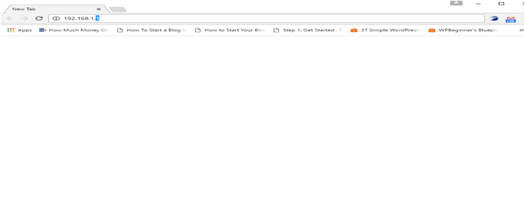

Upon typing, you will be asked for a username and password. Type
Username: admin
Password: admin
Press Enter now.
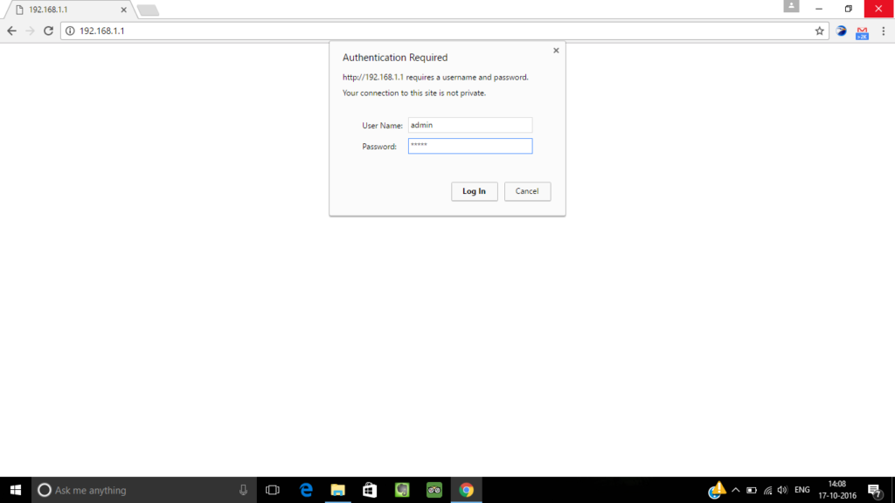

B) Now you will see a device status page.

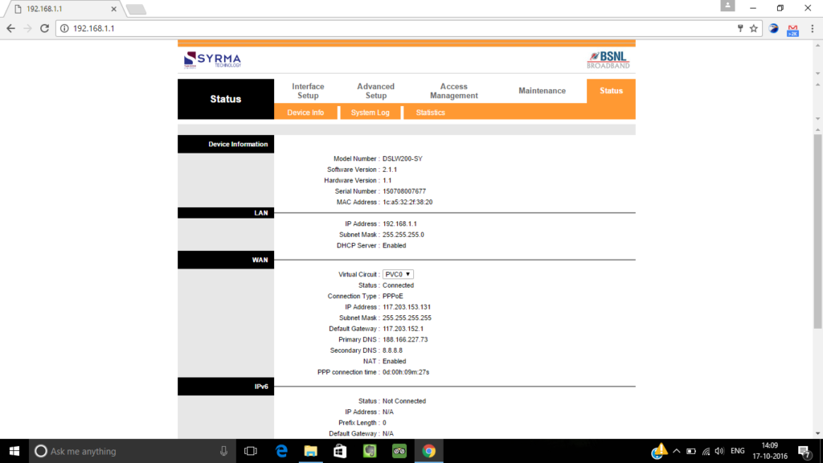

Note: Please click on the Maintenance -> Administration tab and change the Modem access password

Now login with the new password by repeating the step A

C) Now click on Interface setup and then on the internet.
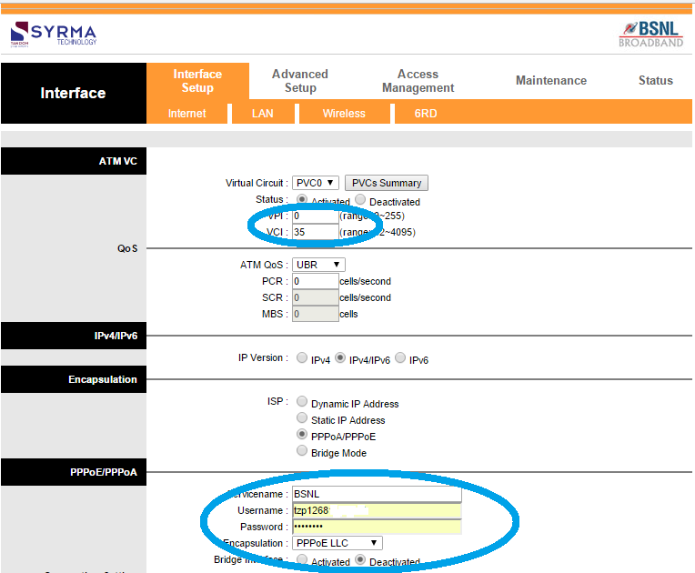

Here you need to select ISP: PPPoA/PPPoE
VPI=0, VCI= 35
And fill service name: BSNL
Username: this will be your broadband user id. BSNL(internet service provider) will provide this at the time of connection. Contact BSNL if you don’t know the username.
Password: password
Once you get you get your username, put it on the appropriate field. After putting username and password click on SAVE button.

D) Wifi Setup
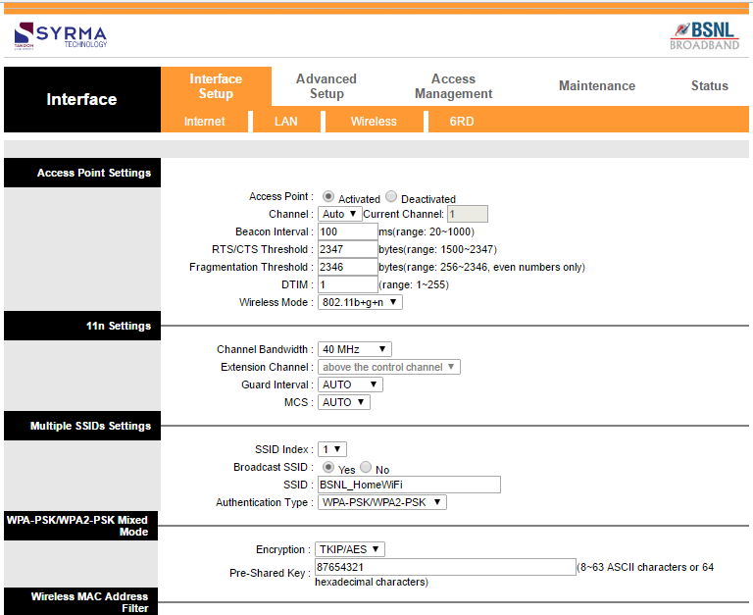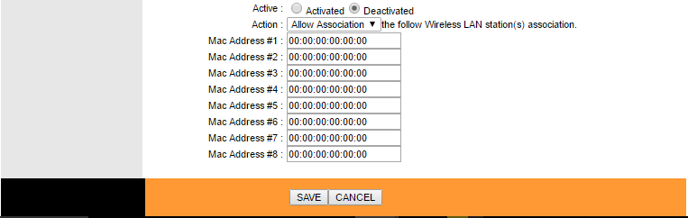

To set up your wifi, click on wireless.
Check Access Point Activated.
Wireless Mode: 802.11 b+g+n
SSID: Put any name here. This will be your wifi access point name.
Authentication type: WPA-PSK/WPA 2 PSK
Encryption: TKIP/AES
Pre-shared key: This will be your wifi password.
Wireless Mac address Filter: Deactivated.
Now click on SAVE button

Click on the Access Management Tab

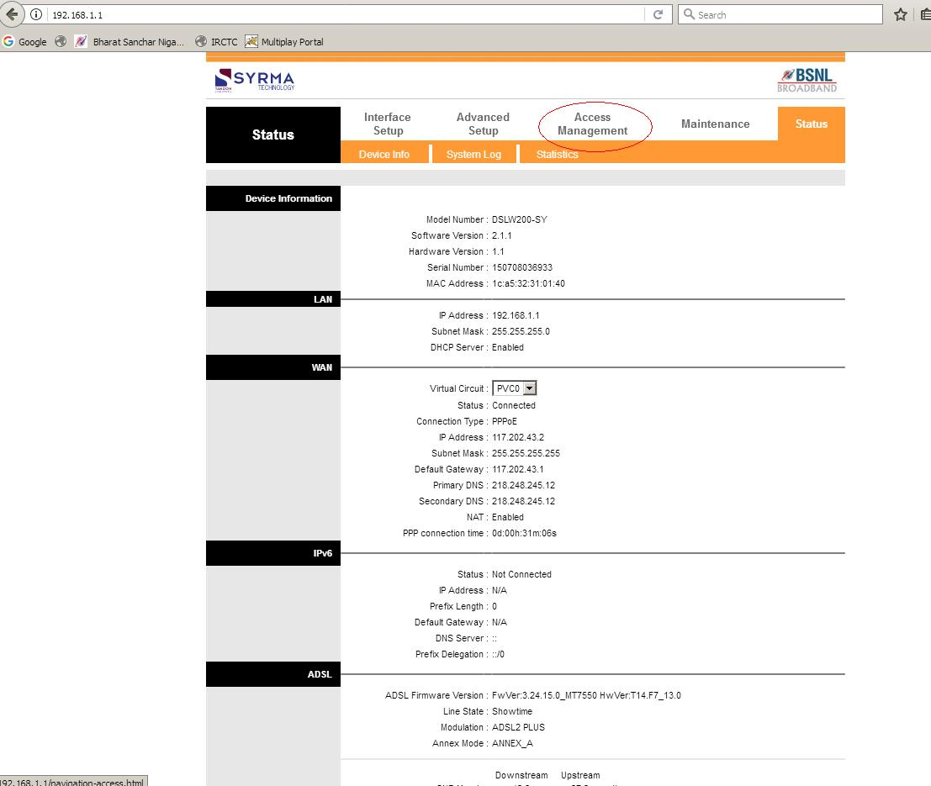

Click on ACL and activate ACL as per the screen below.

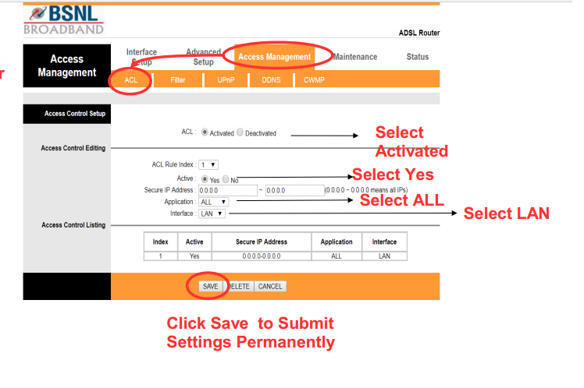

PROCEDURE FOR SECURING TERACOM MODEM

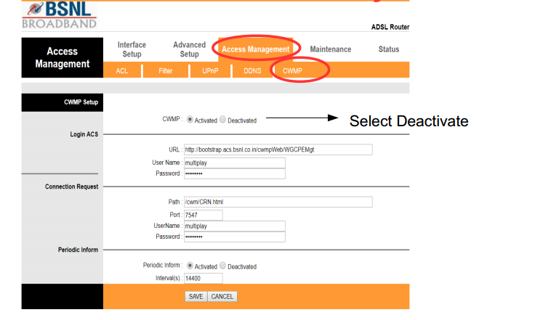
A quick tip, you should change the wifi password of BSNL modem regularly to protect your network.
You have now successfully configured your modem. You will notice that ‘Internet’ LED will now turn green from red and will start blinking.

System restart with current settings Restart



